DOCUMENTATION:Task 3

Name:R.Harini

A Question-Answering system using the Transformers library and FastAPI.

It starts by defining a FastAPI application and importing the required dependencies such as FastAPI, Form, BertForQuestionAnswering, AutoTokenizer, and pipeline.

QUESTION ANSWERING MODEL:

1. The code begins by defining the context variable, which contains a long text describing Kutty.AI and its services.
2. Next, a list of questions is defined. These are the questions you want to ask the model about the given context.

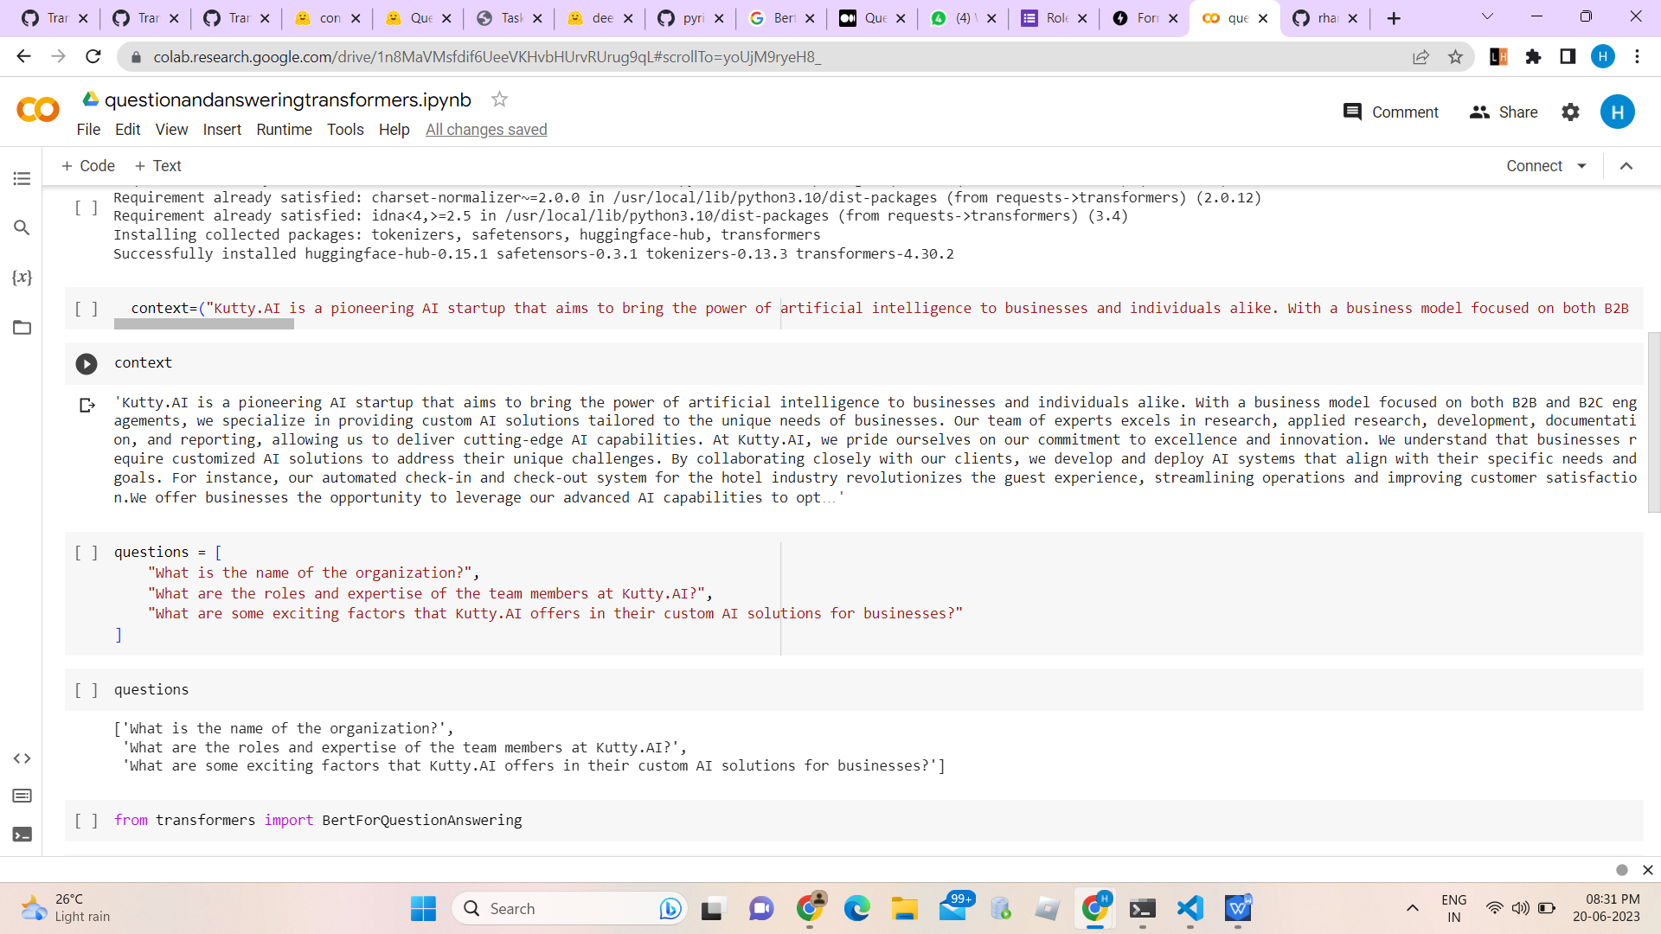

1. The code then loads the pre-trained BertForQuestionAnswering model from the "deepset/bert-base-cased-squad2" checkpoint using the from_pretrained method.
2. The AutoTokenizer class is used to create a tokenizer for the model using the same "deepset/bert-base-cased-squad2" checkpoint.
3. The encode method of the tokenizer is used to encode the first question in the list (questions[0]) with truncation and padding.
4. The pipeline function is used to create a question-answering pipeline with the loaded model and tokenizer.
5. Finally, the question-answering pipeline is invoked with the provided question (questions[2]) and context, returning the answer.

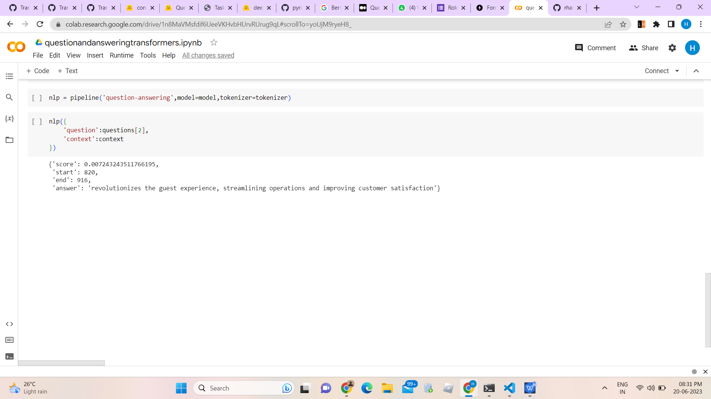

FASTAPI:

1. FastAPI Setup

2.Question Answering Function:Question_answerer function, which utilizes the Transformers pipeline to perform question answering. Takes a question and context as input and returns the answer.

3.Endpoint Definition: The /qa/ endpoint definition

1. Open Command Prompt: Open a command prompt or terminal window.
2. Navigate to the Code Directory: Use the cd command to navigate to the directory where the main.py file is located.
3. Run the Application: Once you are in the correct directory, run the following command to start the FastAPI application using Uvicorn:uvicorn main:app --reload
4. Access the API:API should start running. It will be accessible at http://127.0.0.1:8000/ or <http://localhost:8000/.>

